Decision Tree
1️⃣ What is a Decision Tree?
A Decision Tree is a supervised learning algorithm used for classification and regression that models decisions in a tree-like structure.
It works by splitting the data into smaller and smaller subsets based on feature conditions until a final decision (leaf node) is reached.
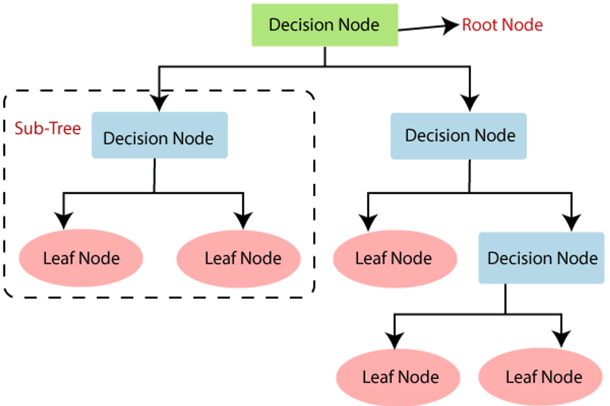
2️⃣ Structure of a Decision Tree
Component | Description
Root Node | First split
Decision Node | Internal node with a condition
Leaf Node | Final output
Branch | Outcome of a test

3️⃣ How Decision Tree Works (Step-by-Step)
- Start with entire dataset
- Choose the best feature to split the data
- Split data into subsets
- Repeat recursively for each subset
- Stop when:
  - All labels are same
  - Max depth reached
  - Minimum samples per node reached

4️⃣ How “Best Split” is Chosen
🔹 For Classification
Common metrics:
✅ Entropy
Measures impurity
$$Entropy=-∑p{log⁡}_{2}p$$
✅ Information Gain
Information Gain
Reduction in entropy after split
$$IG=Entropy(parent)-Weighted Entropy(children)$$✅ Gini Index (used by CART)
$$Gini=1-∑p^{2}$$1️⃣ Gini Index Range (Classification)
Why Do We Need Gini?
At each node, the tree asks:
“How good is this split at separating classes?”
Gini gives a numerical answer to that.

🔹 Binary Classification (2 classes)
$$\boxed{0 ≤\text{ Gini }≤ 0.5}$$
Gini Value | Interpretation
0.0 | Perfectly pure (only one class)
0.1 – 0.2 | Very good split
0.2 – 0.3 | Acceptable split
0.3 – 0.4 | Weak split
0.5 | Worst split (50–50 mix)
📌 Decision Trees try to push Gini toward 0

2️⃣ Multi-Class Gini Range (General Case)
For k classes:
$$\boxed{0 ≤\text{ Gini }≤ 1-\frac{1}{k}}$$
Examples:
Number of Classes | Max Gini
2 | 0.5
3 | 0.667
4 | 0.75

Lower Gini = Better split
Best → 0
Worst (binary) → 0.5

🔹 For Regression
Uses:
- Mean Squared Error (MSE)
- Mean Absolute Error (MAE)
Split that minimizes error is chosen.

5️⃣ Advantages of Decision Tree
✔ Easy to understand & interpret
✔ No feature scaling required
✔ Handles non-linear data
✔ Works with numerical & categorical data

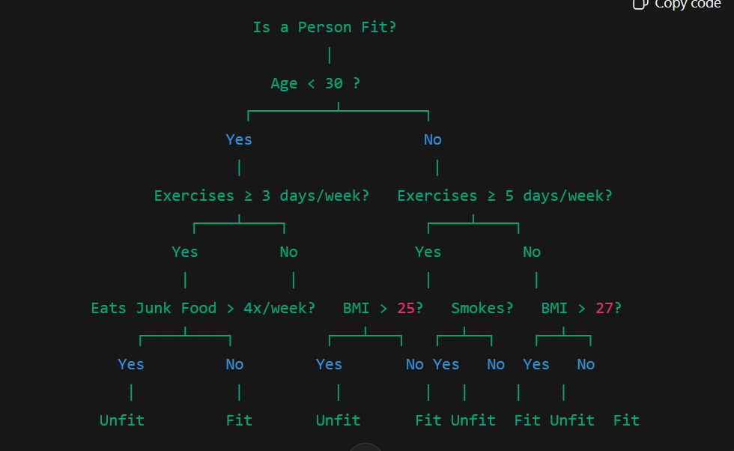

Disadvantages
❌ Overfitting (very common)
❌ Sensitive to small data changes
❌ Can create complex trees
➡ Solution:
- Pruning
- Max depth
- Min samples split

- Decision Tree Overfitting Controls
Decision Trees tend to grow very deep and memorize data, which causes overfitting.
To prevent this, we use:
• Pruning
• Max Depth
• Min Samples Split

1️⃣ Pruning
🔹 What is Pruning?
Pruning means cutting unnecessary branches of a decision tree to simplify the model.
Instead of letting the tree grow fully, we remove branches that do not improve performance on unseen data.

🔹 Why Pruning is Needed
- Fully grown trees:
  - Fit training data perfectly
  - Perform poorly on test data
- Pruning:
  - Reduces complexity
  - Improves generalization

🔹 Types of Pruning
✅ Pre-Pruning (Early Stopping)
Stops tree growth before it becomes too complex.
Uses conditions like:
- Max depth
- Min samples split
- Min samples leaf
📌 This is most commonly used in practice.

✅ Post-Pruning
- Grow full tree
- Remove branches after training if they don’t improve validation accuracy
📌 More expensive, but sometimes more accurate.

🔹 Simple Example
If a split improves accuracy by only 0.2%, pruning removes it.

🔹
Pruning reduces overfitting by removing branches that add little predictive power.

2️⃣ Max Depth
🔹 What is Max Depth?
Maximum depth = maximum number of levels in the tree
Depth 0 → Root
Depth 1 → First split
Depth 2 → Second split
...

🔹 Why Control Max Depth?
- Large depth → complex tree → overfitting
- Small depth → simple tree → underfitting

🔹 Example
Max Depth | Effect
2 | Very simple, may miss patterns
5 | Balanced
20 | Overfits training data

🔹
Max depth limits how deep a decision tree can grow to control model complexity.

3️⃣ Min Samples Split
🔹 What is Min Samples Split?
The minimum number of data points required to split a node.
If a node has fewer samples than this value:
➡ No further splitting

🔹 Why It Matters
- Prevents splits based on very few samples
- Avoids learning noise

🔹 Example
If:
min_samples_split = 10
Then:
- Node with 9 samples → ❌ no split
- Node with 15 samples → ✅ split allowed

🔹 Effect
Value | Effect
Small (2) | Overfitting
Large (50) | Underfitting

7️⃣ When to Use Decision Tree
✔ When interpretability is important
✔ When relationships are non-linear
✔ When data has mixed types
✔ As base model for Random Forest & XGBoost

K-Nearest Neighbors (KNN)
1️⃣ What is KNN?
KNN is a lazy, instance-based supervised learning algorithm used for classification and regression.
It predicts output by looking at the K closest data points in the feature space.

2️⃣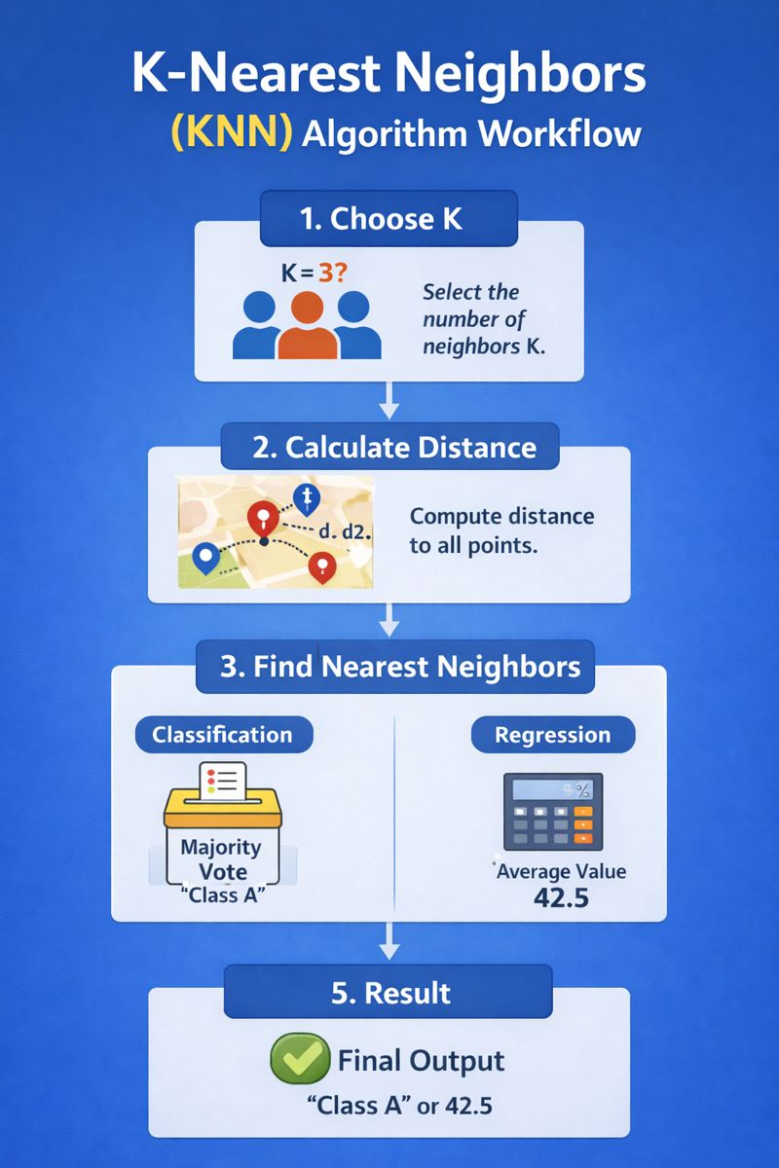
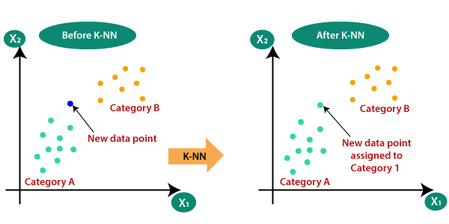
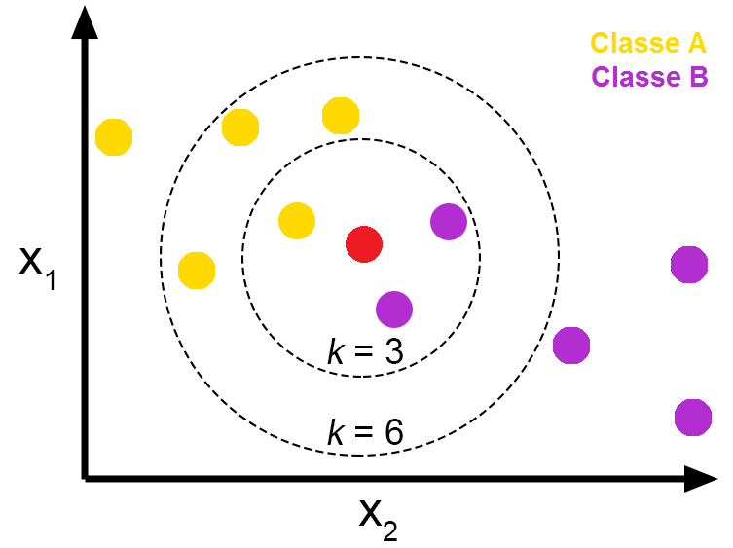
If you have confusion to choose the value of k the simplest way is square root of n, where n is number of rows in train data. It works prefectly majority of times.

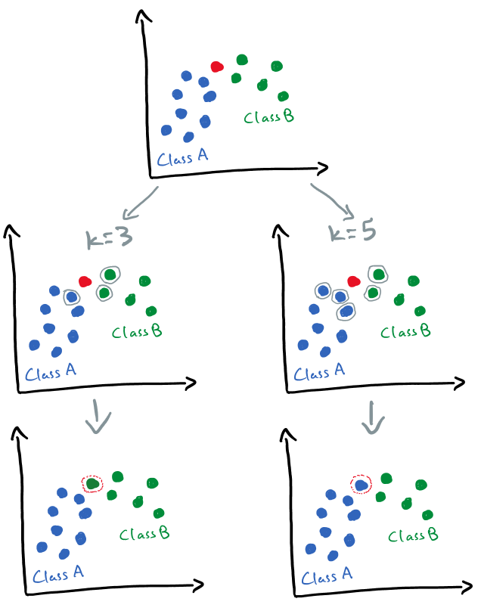

1️⃣ Choose Optimal K using Cross-Validation (MOST IMPORTANT)
What to do:
- Try multiple K values (e.g., 1 to 20)
- Evaluate accuracy using cross-validation
- Pick the K with best validation performance
Why it works:
- Avoids arbitrary K
- Finds balance between overfitting and underfitting
Interview line:
“We select K using cross-validation to minimize generalization error.”

✅ 2️⃣ Use Odd Value of K (Simple but Effective)
Why:
- Prevents tie situations in binary classification
Example:
- K = 3, 5, 7 → preferred
- K = 4, 6 → avoid
⚠️ This does not solve instability, but avoids ambiguity.

✅ 3️⃣ Use Weighted KNN (BEST TECHNICAL FIX)
Instead of simple voting:
$$\text{weight}=\frac{1}{distance}$$
What changes:
- Closer neighbors influence more
- Farther neighbors influence less
Effect on your diagram:
- Even for K = 5, the closest green points dominate
- Prediction becomes stable
Interview line:
“Weighted KNN reduces sensitivity to K by giving more importance to closer points.”

✅ 4️⃣ Feature Scaling (Indirect but Critical)
Why:
- Prevents one feature from dominating distance
- Makes neighbor selection meaningful
Scaling doesn’t fix K sensitivity, but prevents wrong neighbors

✅ 5️⃣ Increase Dataset Size (Often Overlooked)
Why:
- Sparse regions cause instability
- More data → smoother decision boundaries

3️⃣ How KNN Works (Step-by-Step)
- Choose value of K
- Calculate distance between test point and all training points
- Select K nearest points
- Predict:
  - Classification → majority vote
  - Regression → average of neighbors

4️⃣ Distance Metrics
Most common:
✅ Euclidean Distance
$$d=\sqrt{∑(x_{i}-y_{i})^{2}}$$
Other distances:
- Manhattan
- Minkowski
- Cosine similarity

5️⃣ Choosing the Value of K
K Value | Effect
Small K | Low bias, high variance (overfitting)
Large K | High bias, low variance (underfitting)
✔ Use cross-validation to select best K

6️⃣ Feature Scaling (IMPORTANT)
KNN is distance-based, so scaling is mandatory.
Use:
- StandardScaler
- MinMaxScaler

7️⃣ Advantages of KNN
✔ Simple and intuitive
✔ No training phase
✔ Works well with small datasets

8️⃣ Disadvantages
❌ Slow prediction on large datasets
❌ Sensitive to noise
❌ Requires feature scaling
❌ Memory intensive

9️⃣ When to Use KNN
✔ Small datasets
✔ Low dimensional data
✔ Clear cluster separation
✔ Quick baseline model

Decision Tree vs KNN
Feature | Decision Tree | KNN
Type | Eager learner | Lazy learner
Training Time | Fast | Very fast
Prediction Time | Fast | Slow
Scaling Needed | ❌ No | ✅ Yes
Interpretability | High | Low
Overfitting | High | Moderate

